MS Office Excel (Project 3B)
Hey everyone – welcome back! In my next tutorial, I continued to work with the data for the city of Pacifica Bay. The City Manager wanted to estimate future tourism spending, based on two possible growth rates. So, I created a line chart.

In cell B4, I typed “2010”, pressed “Tab”, and entered “2011” in cell B4. Next, I highlighted the range from B4 to C4 and used the fill-down tool to draw and drop my values horizontally to the right through cell C4 so that my years were set from 2010 to 2014.

In cell C6, I typed in the following formula:

=(C5-B5)/B5

Then, I used the fill-down tool to draw and drop my values horizontally to the right through cell F6. Next, I formatted my values as percentages with zero places to the right of the decimal point.

I clicked on cell A2, navigated to the “Home” tab, went to the “Clipboard” group, and selected “Format Painter”. Then, I clicked on cell A8 to apply the format. I selected cell F5, right clicked, and chose “Copy”. I clicked on cell B13, right clicked, and selected “Paste” under “Paste Options.

The economic data suggests that future growth will trend close to that of the recent past. To plan, the City Manager wants to prepare a forecast of tourism spending, based on the percentage increase halfway between the high of 29% and the low of 21% at 25%. To do this, I entered in the following formulas in cell C13:

=B13*(100%+$B$10)

Then, I used the fill-down tool to draw and drop my values horizontally to the right through cell F13.

A growth rate of 25% in tourism spending in each year will result in tourism spending of approximately $27 million by 2018. The city planners wanted to know what will happen if tourism spending grows at the lowest rate of 21%. Since formulas are constructed to use the growth rate that is in cell B10, the City Manager was able to answer that question when I entered a different percentage into that cell. Since I wanted to keep the results of the new calculation so that it can be compared, I pasted the results of the What-IF question into another area of my worksheet.

In cell A15, I typed “Estimated Growth in Tourism Spending 2014 to 2018”. Next, I clicked on cell A8, navigated to the “Home” tab, went to the “Clipboard” group, and selected “Format Painter”. Then, I clicked on cell A15 to apply the format. I selected the range from A10 to B10, navigated to the “Home” tab, went to the “Font” group, chose the “Fill Color” and selected the third color in the first column, “White, Background 1, Darker 15%”. In the range from A17 to A19, I typed in the following row titles:

- Year
- 25% Growth Rate
- 21% Growth Rate

I selected the range from B12 to F12, copied it, and pasted it in the range from B17 to F17. I repeated this step for the range from B13 to F13. But this time, I right clicked on “Paste” and under “Paste Options”, I selected “Paste Special” under “Special Values” and chose “Values & Number Formatting” for B18 to F18. In cell B10, I changed the value from “25” to “21”. When I did this, my values in the range from C13 to F13 changed. Then, I repeated the same steps as I did for the range from B18 to F18.

City Council members wanted to see how tourism spending increased over a 5-year period. So, I created a line chart for them. A line chart shows trends over time. Time is shown at the bottom axis and the data point values connect with a line. The curve and direction of the line make trends clear to the readers. First, I navigated to the “Page Layout” tab, went to the “Themes” group, clicked on “Colors” and chose “Orange”. Next, I highlighted rows 8 to 24, right clicked, and chose “Insert” to insert new blank rows. Then, I selected the range from A5 to F5, navigated to the “Insert” tab, went to the “Charts” group, clicked on “Line Charts” and selected “Line with Markers”. In the chart title, I pressed “Enter” typed “Tourism Spending 2010 to 2014”. So, “Pacifica Bay” was on the first line, “Tourism Spending 2010 to 2014” was on the second line. Then, I set the color to “Black, Text 1” with a bold, font style.

The axis is the line that references the measurement for the area of the chart. In a line chart, the categories of data are horizontal on the X-axis. The range of numbers is vertical on the Y-axis. Since I wanted to adjust the X-axis to show the years, I selected the X-axis, right clicked, and chose “Select Data”. When I clicked “Select Data”, I got a “Select Data Source” pop-up window.

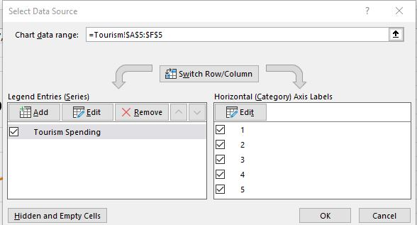

In the “Horizontal Axis Labels” section, I clicked on “Edit”. When I clicked on “Edit”, I got a “Axis Labels” pop-up window:

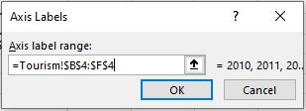
In the “Axis Label range” field, I set my range from B4 to F4. I clicked “OK” to close the “Axis Labels” pop-up window. Then, I clicked “OK” to close out the “Data Source” pop-up window. I right clicked the X-axis, selected “Format Axis”, and chose “Fill & Line”. Under “Line”, I chose “No line”.

Lastly, I formatted the chart area. I selected the chart, right clicked, chose “Format Axis”, and chose “Picture or gradient fill”. Then, I navigated to my files and chose the “Surfers” JPEG image. In the “Border” section, I set the “Width” to “4 pt” and checked off “Rounded corners”. I selected the horizontal gridlines, set the color to “Orange, Accent 1” in the fifth column with the first color and adjusted my “Width” to “1 pt”. Next, I right clicked on my X-axis, selected “Font”, and set the color to “Black, Text 1” in bold. I also repeated this step for the Y-axis too.

So, this is how I created a line chart. Hope this tutorial was helpful, and I’ll see you in the next one!

